6th International Conference on Smart Applications, Communications and Networking
28 - 30 May 2024, Harrisonburg – Virginia, USA
https://smartnets.ieee.tn/

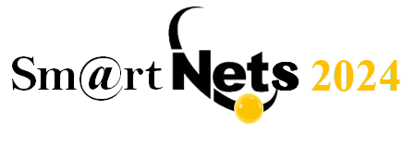

PARTNERSHIP CONFIRMATION FORM

We wish to be an official partner of the 6th International Conference on Smart Applications, Communications and Networking (SmartNets 2024)

- Diamond Partner
- Platinium Partner
- Gold Partner
- Silver Partner
- Bronze Partner
- Industry Exhibit
- Academic Exhibit

Organization : __________________________________________________________
Address : ______________________________________________________________

Signature: _____________________________________________________________
Title : _________________________________________________________________
Telephone : _____ _____-__________
Email : ______________________________________________________________

Date : ______________________________________________

Please fill in this form and send it by email to :
smartnets@ieee.org / salmanaa@jmu.edu / eltawass@jmu.edu

THANK YOU

